№3
Создать таблицу с количеством использования функций, используя data_for_merge.csv, заполнить ее через оператор merge. Итоговая таблица с результатами должна иметь вид
Function_name | Function_count
CASE | 4
CAST | 2
CONCAT | 7
…
SELECT DISTINCT Function_name , COUNT ( Function_name) AS Function_count
FROM
(SELECT Alex, Carlos, Charles, Daniel, Esteban, Fred, George, Lando, Lewis
FROM [dbo].[data_for_merge]) p
UNPIVOT
(Function_name FOR Employee IN
(Alex, Carlos, Charles, Daniel, Esteban, Fred, George, Lando, Lewis)
)AS unpvt
GROUP BY Function_name;

СНАЧАЛА НЕ ЧЕРЕЗ МЕРДЖ:))
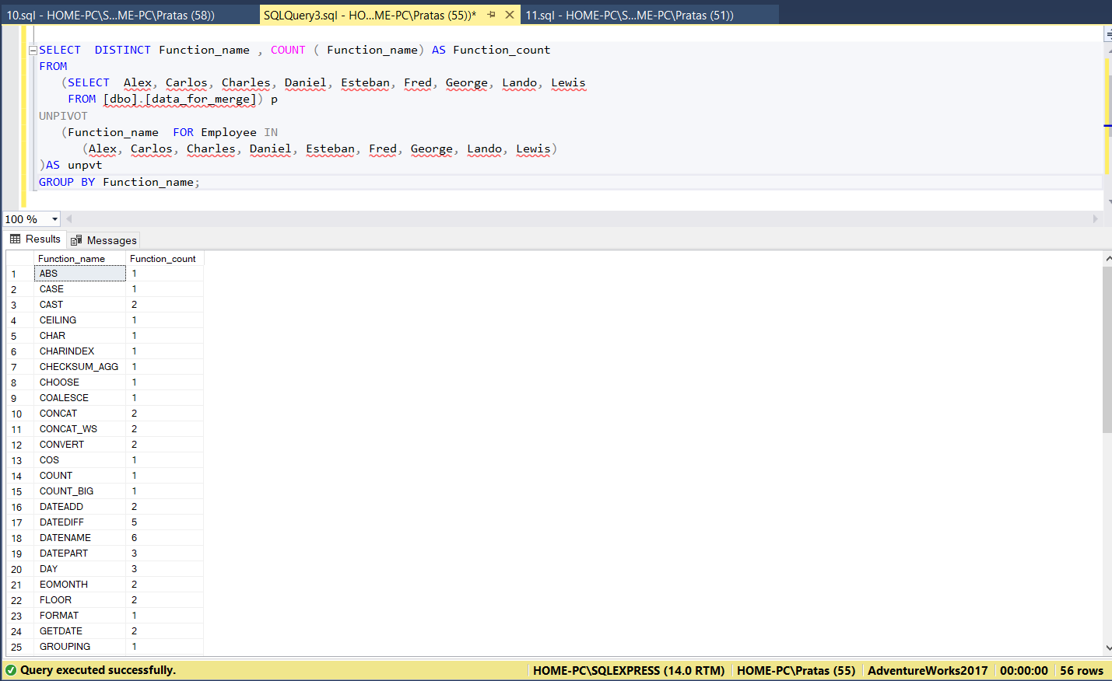

CREATE TABLE CountFunctions
(Function_name NVARCHAR(50),
Function_count INT)

MERGE dbo.CountFunctions target
USING
(SELECT DISTINCT Function_name , COUNT ( Function_name) AS Function_count
FROM
(SELECT Alex, Carlos, Charles, Daniel, Esteban, Fred, George, Lando, Lewis
FROM [dbo].[data_for_merge]) p
UNPIVOT
(Function_name FOR Employee IN
(Alex, Carlos, Charles, Daniel, Esteban, Fred, George, Lando, Lewis)
)AS unpvt
GROUP BY Function_name) source ON target.Function_name=source.Function_name

WHEN MATCHED THEN
UPDATE SET target.Function_count =source.Function_count
WHEN NOT MATCHED BY TARGET
THEN INSERT (Function_name, Function_count)
VALUES (source.Function_name, source.Function_count)
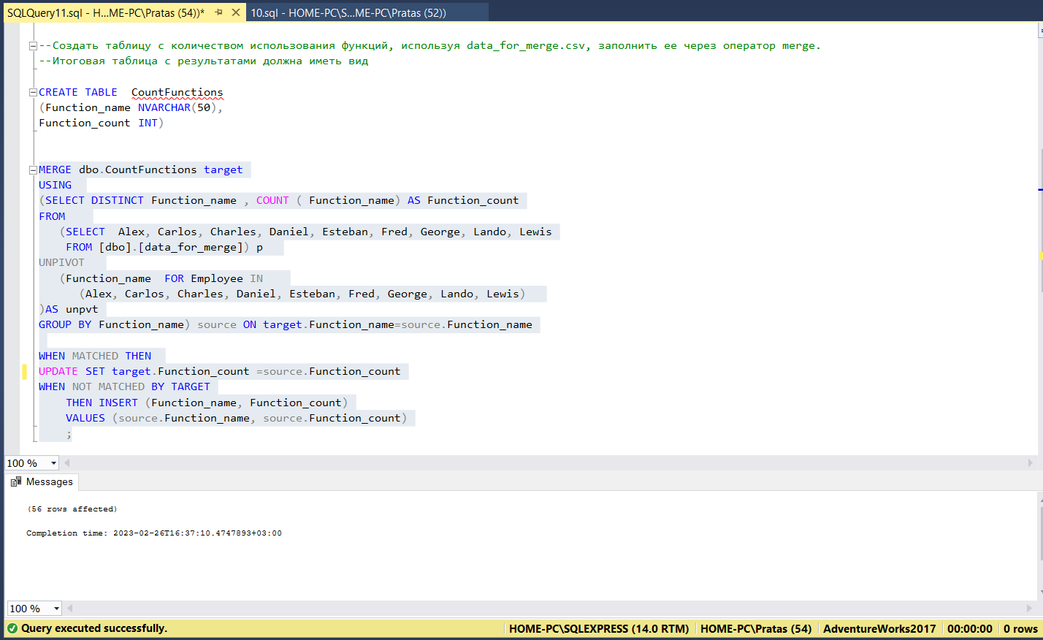

Если заселектить таблицу:
